SPARC
Self-Powered Autonomous Refuse Cart
Alexis Drayton, Sean McGarvey,
Wyatt Schmitt, and Chris Vento
Dept. of Electrical Engineering and
Computer Science, University of Central
Florida, Orlando, Florida, 32816-2450

Abstract — This paper details the design process for the Self-Powered Autonomous Refuse Cart. This slow moving, self-directing crawler is designed to automate the mundane chore of taking out the trash. This product will essentially replace the need to remember to take your trash to the curb by autonomously moving the trashcan on a time schedule. The SPARC will be able to avoid obstacles using its onboard sensors on its journey to the curb and back. The product consists of the SPARC unit which will be a four wheeled crawler, equipped with a camera and sensors for vision that the user can tightly strap their trashcan to and communicate with via a mobile application connected using Bluetooth and the Home Base which will be its charging station.
Index Terms — Application Software, Automation, Bluetooth, Computer Vision, Home Automation, Mobile Communication, Simultaneous Localization and Mapping.

I. Introduction
As the world’s technology progresses, the automation of mundane tasks is on the rise. Online shopping, food delivery services, self-checkout machines and self-driving cars are all examples of this progress and trash collection should not be an exception. In many domestic settings, the trash collection process includes having to move a large trash container to the curb side in front of your home for pick up at a specific time weekly. This task is simple and routine for a lot of people but again as we progress in technology, if the task is simple and easy why not made it automated and efficient.
To automate this process the Self-Powered Automated Refuse Cart (SPARC) will be designed as a rechargeable, motorized, load-bearing crawler that can mount a compatible garbage capable of automatically delivering the garbage bin and its contents to a predetermined location for it to be collected with accordance to a defined schedule. The process is automated by using computer vision and a machine learning pathing algorithm to navigate around any obstacle it might encounter on its journey from the user’s garage to the curbside for pick up. A camera will be mounted on the device to give it the “sight” it needs for its obstacle avoidance capabilities. For charging the SPARC will have a “Home Base” which will wirelessly charge the SPARC when it returns from the curb. The SPARC will utilize GPS technology to know the locations of the curb and the home base for return. The central control unit of the SPARC will be its microcontroller which will house its movement controls which will take input from its path finding algorithm with takes data from its visual sensors. The movement functions can also take in input via Bluetooth from the user mobile application. Users will also be able to program their garbage collection schedule into the SPARC by using this companion smartphone app for the Android OS. Physically the SPARC will include waterproofing of its electrical components and will be able to withstand a garbage load up to 50 pounds and hold a charge capacity that will be enough to traverse an average driveway and make a return trip back to the home base for recharging and garbage reloading.
Ultimately, the SPARC is meant to facilitate the user’s day to day routine by eliminating the need to think about taking out the trash. The final design of the SPARC will be implemented in the most cost-effective way possible. This project has been generously funded by Selah Group Florida, Inc but kept on a tight budget. The SPARC’s end goal is to be a user-friendly device that will ease the user’s mind by eliminating the need for such a mundane task that will leave room for more important things.

II. Overview
This section will provide an overview of the project, giving details of the project motivation, project objectives, requirements specification and an outline of our products wants versus the capabilities of the project.
There will be three units that comprise the SPARC system; the SPARC unit itself, and SPARC’s “Home-Base” platform, and a colored stake to mark the approximate destination for curbside position accuracy. The SPARC unit will require charging through a NEMA 5-15 standard 120V wall outlet, and will ideally be charged later automatically and autonomously through solar panels built into Home-Base. When powered, the user can pair his/her smartphone to SPARC through Bluetooth. Then the user should select which days of the week their local garbage collection takes place. The SPARC will be designed to accommodate the square garbage bins utilized by semi-automated, side-loading garbage collection vehicles. This garbage can will be firmly attached to the SPARC unit, primarily via a clamp to the wheel axle of the garbage can in the rear, and grips in the front corners. The weight of the SPARC unit needs to be heavy enough to offset weight from the trash can to prevent toppling while moving.
Once a location for the Home Base has been chosen, the platform has been placed on the ground, and the SPARC unit has been initially charged, the user’s ideal path has been initialized, and programmed with the user’s desired delivery schedule, the SPARC will wait in standby mode until a pre-programmed time on the morning of the collection day. At that time, the device will power on and check its location compared to the first node in its path. The SPARC will pilot itself using its pathing algorithm in order to reach the destination. SPARC will utilize obstacle avoidance technology to prevent collisions with parked cars and maneuver around other such obstructions during its trip, and will automatically find new paths and will greedily choose one which puts it in a greater proximity to its destination. Once the cart has arrived at the GPS coordinates of the drop-off point, the SPARC will then utilize its visual sensors to determine where the curb is in relation to the SPARC referencing the colored stake, at which point the SPARC will use this information to rotate itself, and move up against the curb. Then it shall switch to a low power state, and wait for garbage collection.
After garbage collection, during a user programmed time, the SPARC unit will power on again, and deploy the same pathing algorithm to return to the Home-Base safely. Once at the Home-Base, SPARC will deploy a “charging arm” on the underside of the unit, which will make contact with a wireless charging pad, to facilitate recharging of the battery built into the SPARC unit. At any given time, the user should be able to use the smartphone app to assume direct control of the SPARC unit, which is connected to the microcontroller via Bluetooth, using a GUI control system to pilot the SPARC at will. The app will also give the user an interface for controlling the time of day the SPARC will deliver its payload and when it will return to its Home-Base based on their trash collection schedule. Figure 1 below shows the top level break down of all components of the SPARC and the division of labor amongst the group. The components in the diagram where the first set designed for the SPARC. Future renovations of the design excluded the use of solar panels where our newest design accommodates for the power by keeping the home base plugged into a wall outlet as a more effect way of receiving power.
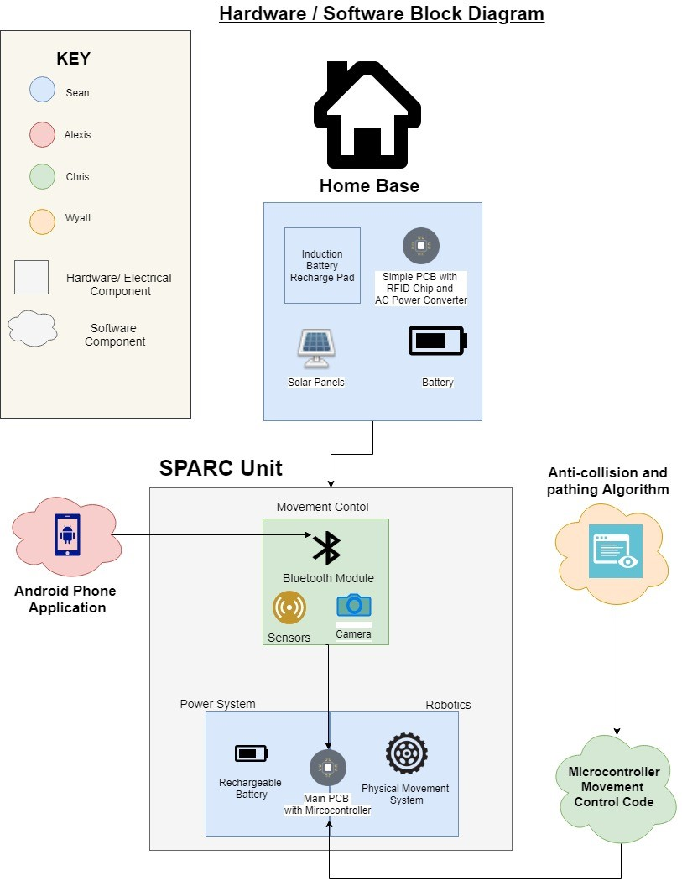
Fig. 1. Initial Concept Block Diagram
Figure 1 demonstrates the concept flow of both the home base and the main SPARC unit with both software and hardware components. The home base will be constructed as a purely hardware powering service for the SPARC unit, with an AC/DC Wall Connector, and a metal Pad for contact with another Metal Pad on the main SPARC Unit. The home base will be connected using a simple PCB equipped with an RF chip for SPARC positioning on the return path. The SPARC unit has three major connecting components; the movement control, power system and robotics. The movement control components include the Bluetooth and GPS modules, which will connect to the main PCB equipped with a microcontroller. The main PCB also controls the physical movement system which will consist of the motors, chassis and treads. The software components connect include the mobile app, which controls the SPARC unit via the Bluetooth module, and the pathing algorithm and movement code which is loaded into the microcontroller directly.

A. Project Objectives
In creating this project, our main goal is to ease the users mind when it comes to remembering to take out the trash or in some cases help those who are not able to take out the trash on their own to aid in their individual independence. To achieve our main goal, we have some desired technical objectives for the SPARC:
• Autonomous Control
• Remote Control
• Device Scheduling
• Path Mapping and Localization
• Obstacle Avoidance
• Wireless Charging
Ultimately the SPARC will be a fully functional transport cart that will map its local area using its camera to create a path to a desired location and autonomously move there at the desired time. The SPARC will be able to be remotely controlled as well via the mobile application. The device will also be scheduled on this mobile application. The pathing algorithm the SPARC uses to move to and from the Home Base and the user’s desired destination in a self-mapped problem space aided by GPS. The SPARC will additionally have obstacle avoidance capabilities using visual sensors. Once the SPARC returns to the Home Base it will wirelessly charge in a low powered state until triggered by its set schedule. The following sections will serve as an overview of the two main components of the SPARC, the hardware and the software, and break down their individual subcomponents.

III. Hardware Design
The hardware of this project has continually proven to be a very time intensive aspect of this project in both research, design, and implementation. Not only do the motors need to be able to pull 45 Pounds on top of the weight of the chassis, the Printed Circuit Board needs to deliver enough current to these motors to allow them to function properly. This is made possible using 32 Lithium Ion 18650 Batteries pushing a maximum of 20A (10A to each motor) through 10 paralleled Voltage Regulators.
In addition to this, we have a second Printed Circuit board that converts power from a standard wall outlet to a voltage that is usable by the SPARC unit to facilitate battery charging. The SPARC unit talks to the Charging Base on a rudimentary level using simple RF transmitters. These transmitters allow us to enable or disable the output of the Charging Base.
A. Motors
The Motors we used on this project are two DC Motors, each with 17200 RPMs and an output torque of 4.47oz-in. These go through an 81:1 Gearbox which allows us to lower the high RPMs down to 212.2 RPMs. It also increases the torque proportionally to 362.07 Oz-iz. This will allow us to move the weight we need to move. The Motors are controlled by two H-Bridge Motor Controllers. An H-Bridge allows the polarity of the output voltage to be switched, given a command signal from the Microcontroller. This allows us to make the Motors run in reverse, which helps our turning ability, as well as gives us the option of moving in full reverse given a situation where the SPARC becomes trapped by obstacles and needs to back out of its current position.
B. Battery Bank
The Battery Bank of this project has been comprised of Thirty-Two (32) High-Drain 18650 Lithium Ion Batteries, each with a Nominal Voltage of 3.7V and a capacity of 2500mAh and a Maximum discharge rate of 20A. These batteries have been arranged in a 4-Series, 8-Parallel configuration, providing a Nominal 14.8V output with a capacity of 20,000mAh at a Maximum discharge of 160A. The High drain batteries were chosen in an early design stage when we had less cells in parallel, which would have put a higher demand per battery. The Battery Bank itself only needs to be able to output 20A under the most extreme conditions, which would require each battery to contribute 2.5A at any given time.
The Battery Bank can receive an input from the Charging Base, nominally 16V with a maximum of 3A. This input is routed through an array of Charge Protection chips, to prevent Overcharging, in terms of both Over Voltage and Over Current. Under Optimal Conditions, the Battery Bank will have the ability to full charge all 20,000Ah in 26.67 Hours, which is allowable given the downtime between usages.
C. Voltage Regulators
The SPARC Unit has 5 different Voltages running across the PCB. The first two have already been discussed, being the 16V input from the Charging Base, and the 14.8V Output from the Battery Bank. From there, voltage regulators will take an input of 14.8V from the Battery Bank, and step it down to 12V for the Motors, 5V for the IR Sensor and USB Port to the PixyCam, and 3.3V for the Microcontroller, Bluetooth Module, GPS, the H-Bridge Logic Control, and RF Transmitters. As there is almost Negligible Current being drawn from the 5V and 3.3V devices, only 1 regulator is necessary for each of these voltages. The 12V Circuit, however has a max Load of 20A. As each Regulator has a Maximum output of 2A, we decided to put ten (10) of the 12V Regulators in parallel, to allow for the required current. The 5V and 3.3V regulators have been configured to be in an “Always On” configuration, to ensure that the Logic aspect of the board never shuts off. The 12V array, however has been designed to allow the circuit to be disabled via a signal from the Microcontroller.
D. Home Base
The Home Base is the section of the project that deals with Charging the main SPARC unit. This Circuit is fairly simple, as it is only a Voltage Step Down from out wall adapter, with some basic Logic added to the circuit. Initially, the Home Base receives an input from an AC/DC Wall Adapter. The one we are using is set to 18V at 3A, However the limitations of the chips in the circuit would allow for anything up to 25V at 6A.
From the input, we have an “Always On” 5V Regulator which powers the RF Receivers, which are set to receive signals from 433 MHz and 313 MHz Antennas. These signals are then routed through an SR-NOR Latch, which Enables or Disables the output of Three (3) 16V Regulators that are also tied to the input. The Output of the SR NOR Latch holds its last known state, So even if the “Enable” command is only picked up for a second, The Latch will Enable the output indefinitely until it receives a Disable Command.
E. Structural/Chassis Design
The Structural aspect of the Chassis will be very minimalistic and functional. The goal of this project is not to design a stylish Chassis, however it is to make a functional device. Because of this, our chassis is Going to be a simple box made out of Aluminum. Inside the Aluminum Box, there will be a piece of plywood that the Circuit Board will be strapped to as an insulator between the Circuit Board and the Chassis. The Motors will bet mounted on the underside of the Aluminum Box in the Front Side, where the back side will have Caster Wheels to allow for easy turning.
On the top side of the Aluminum Chassis will be a Two Metal bars bolted to the Chassis itself. This will allow a Trash Can to be attached with tension straps. Figure 2 below shows a Concept Illustration of the SPARC unit. During this phase of the concept, we were using 6 wheels, however as stated above we are only using 2 powered wheels and 2 Caster Wheels.
The Chassis will be formed together using simple metal brackets as well as epoxy, While a section will be removable for maintenance procedures. The removable section will be sealed with Automobile Weather Stripping to prevent water from entering the Chassis while in a rainstorm. As an outdoor device, the ability to withstand a standard storm (not including a Hurricane or Flood) is a necessity.
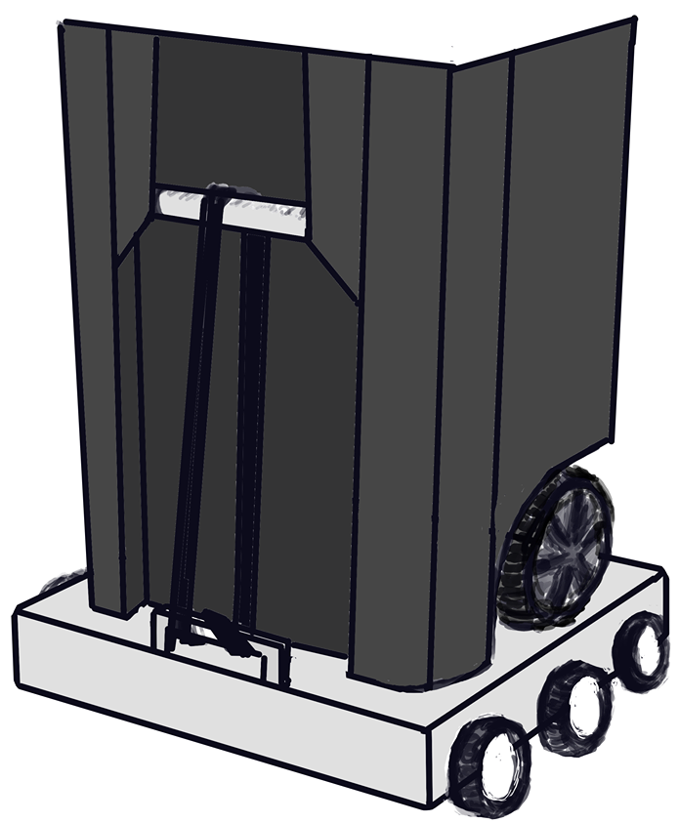
Fig. 2. SPARC Unit Concept Art

IV. Software Design
The other main component of this project is all the software needed to control this device. There are three main parts of the overall software of the SPARC device. Firstly, the most low-level software of the SPARC is the programming of the microcontroller which will serve as the main processing unit of the SPARC. All the basic movement control functions will be programmed into the microcontroller receiving input either from the path algorithm for autonomous movement or from the mobile application via Bluetooth for remote controlled movement. The next software aspect is the mobile application itself. This will serve as the main port for the user experience of the SPARC device. The user interface will be intuitive and easy to use to maximize user satisfaction. Lastly the most computationally intensive software component will be the pathing algorithm. This will be the brains from the autonomous control of the SPARC device. Figure 3 below is a use case diagram for the SPARC’s different software components. The user never interfaces with the algorithm or embedded code directly; all user input is delivered to the system through the Android Mobile Application.
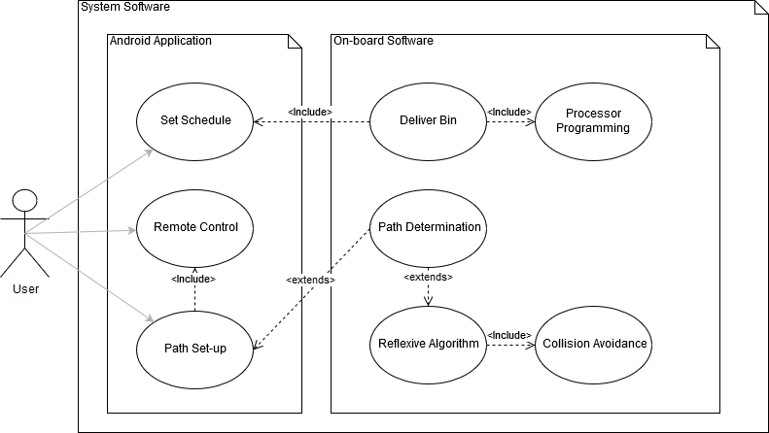
Fig. 3. Software Use Case Diagram

A. Microcontroller
We primarily considered two different models for our microcontroller. The initial consideration was the MSP430 from Texas instruments. The MSP430 was designed for low cost and, primarily, low power consumption applications. In terms of budget restrictions, the MSP430 variants would provide good performance while still being an affordable option. Additionally, the MSP430 Launchpad, a development board, included multiple timers and systems to handle interrupts and low-power modes. The benefits of this chip also included the past experience of its use already gained through previous courses. The other microcontroller we considered, and ultimately chose, was the Arduino Zero’s chip. This chip is comparable to the MSP430 in many ways, however it has better specs than that of the MSP430 and has a large open-source community with resources and references that may provide guidance or troubleshooting. These benefits come at a higher budgetary cost. Moreover, the camera we have chosen for the computer vision aspect of our design has built-in libraries specifically for use with Arduino chips.
The microcontroller will be programmed using C language, which was one of the deciding factors for choosing our specific microcontroller, the ATSAMD21J18A-AUT, due to our familiarity with coding in C for microprocessors. The microcontroller will be receiving a variety of sensor inputs as well as input from a mobile app for manual controls through a Bluetooth module, and these inputs will be accounted for through the programming of the microcontroller. That familiarity, however, has been gained using one specific model of microcontroller. We are most familiar with programming using the Texas Instruments MSP430 model, but we opted for the microcontroller that is on the Arduino Zero board. This change of platforms will require some adjustment, but the basic skills and concepts required for programming a microcontroller will likely carry over to the unfamiliar platform. Additionally, the benefit of using an Arduino microcontroller is that it is very beginner-friendly and has a large hobbyist community supporting it.
The Arduino community has a large collection of libraries, tutorials, and guides that will be utilized to make the software design process as smooth as possible. Along with standard libraries, there are other additional libraries that are controller-specific that can be used to perform more specific tasks on this specific microcontroller. There are also contributed libraries created by the community that are available for public use, along with numerous project tutorials that may provide explanations or good-practice methods for programming.
The SPARC unit’s motion is created by supplying power to the left and right tracks for a specific interval of time. This is controlled via signals given by the microcontroller that are based on both sensor and mobile app input. Additionally, the microcontroller will be constantly checking the sensors to determine if it can continue its designated path or if it needs to reroute its path to avoid an obstacle. These factors will be addressed using a combination of movement control functions, input control functions, and output control functions.
The movement control functions encompass the core movements the SPARC device will use to traverse its path and correct its course. The device will move forward by having one motor run clockwise and the other anticlockwise, which will cause the tracks to move in the same direction. The device will reverse by running the motors in the opposite direction of the forward movement function. Due to the nature of using timings to determine how long a motor should run, the times for each track may need to be different to ensure straight motion. The input control for the device dictates what the SPARC will do based on what inputs it receives from its modules and sensors. The goal is for the unit to make it to the curb with the trashcan and back without having any collisions, so therefore the input control programming will need to know how to handle its sensor and module inputs and where to send them. The output control for the SPARC device will primarily serve as the structure for when the device will emit a signal or provide feedback via the app. This feature will allow for higher accuracy when determining the location of the device as well as allow it to handle the scheduling for when it is supposed to move to the curb. The output control will send status updates to the user as it performs its tasks and will work in tandem to the input control in order to output the correct responses to specific inputs.

B. Mobile Application
The user experience with the SPARC remains one of the number one priorities in the construction of this product. The main haven for this user experience will be the mobile application. Users will need an easy way to “talk to”, monitor and control the SPARC. The Mobile Application will be that main connection between User and Device. The application will be a simple Android application with options for the user to manually control the SPARC, to schedule the service in time intervals, and to view its GPS location. The application will also be vital in the initial setup of the SPARC.
To control the SPARC, the Mobile Application will have to connect to the device in such a way that it can wirelessly transmit commands to it. Multiple options were considered to transmit these commands. Ultimately, Bluetooth was chosen due to is simple connection and despite its low transmit range as the SPARC device, for the prototype, the user will be in close proximity to the SPARC. Bluetooth connectivity can be easily achieved on Android Applications via Android Bluetooth APIs. These APIs (Application Programming Interface) allow applications to wirelessly connect to other Bluetooth devices, enabling point-to-point and multipoint wireless features. The state functionality of Bluetooth used in the Mobile application is shown in Figure 4. The SPARC will utilize the HC06 Bluetooth module which can be paired with the phone in the user’s phone settings. The pairing code for this module is simply “1234”. If not paired already, the application will pair with the HC06 once it is selected from the list of scanned devices and receives the code.
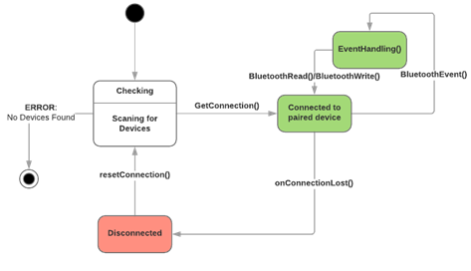
Fig. 4. Bluetooth State Diagram used in the SPARC Application
To send User Commands, each option will simply send a single ASCII character through Bluetooth to the Microcontroller which will then go through it’s receive buffer, and when it revives a specific character it will execute the specified command. For Movement controls the Application will send the SPARC a character to say that it is ready to send movement commands, once the SPARC sends back a ready character to the application, then User can begin pressing the controller like buttons to move the SPARC in real time. For scheduling, the user will input the time, day and frequency via ASCII characters during the initial setup of the SPARC. The microcontroller will save this schedule and execute the path made initialization using its internal clock.
The user interface design for the SPARC is simplistic in nature, designed for the ease of the user. Designed in Android Studio, the application will consist of 5-6 different screens. The Splash Screen for startup, the sign in screen, the signup screen, where data will be collected to create the users unique account, the main screen, which will have the device controls, shown in Figure 5, and the settings options displayed and the setting screen, which will display all the user and device options to have full control over the SPARC device.

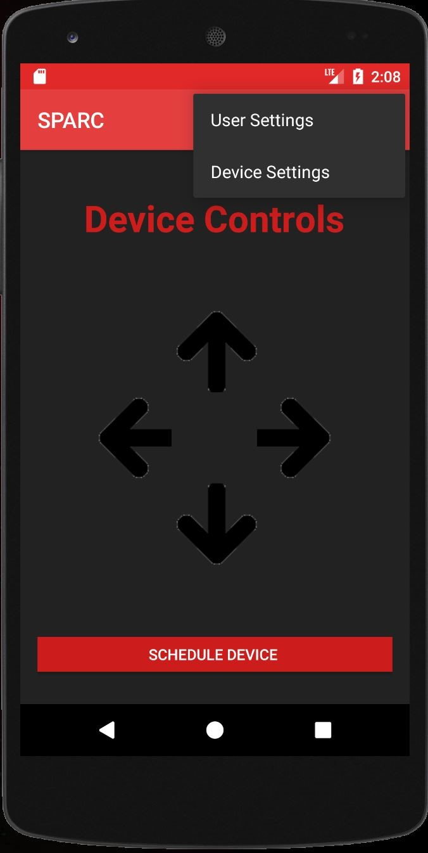
Fig. 5. User Interface Design for the Device Control Screen on the Mobile Application
The device Controls Screen is where the user will take up manual control of the SPARC device either in the initial device set-up or at any time the user requires. The controls include forward, back, left and right and the simple user interface is designed to be like video game or RC car controls. There will be a “Schedule Device” button for easy access to rescheduling the SPARC service. On the top right of the screen, Settings for the SPARC service is split into Device Settings and User Settings. The device setting includes the device controls and schedule service options but in another place other that the home page. Also on/off controls can be specifically uses under these settings and in case the SPARC has disconnected from the user’s device, device settings will be where the Bluetooth options will be. The User settings include regular account settings like Sign Out or Change Password and notification settings as the user can receive notifications for SPARC events.
C. Pathing Algorithm
The software onboard the SPARC crawler will enable it to drive itself from the home-base to the user’s designated drop-off point and vice versa while while detecting and maneuvering around obstacles it finds in its way. The only input from the user besides placing the Home Base and colored stake landmarks is initializing their desired path from Home Base to trash collection endpoint. The SPARC avoids obstacles and creates new paths in its problem space as necessary with fully autonomoy thereafter.
The SPARC conveys information about its surroundings to its algorithm software using an infrared rangefinder and the CMUCam5 Pixy integrated Computer Vision solution. The SPARC's pathfinding algorithm uses this data to map its surroundings and orient itself in real time using these inputs to deliver itself to the Home Base and the user's staked endpoint. In Figure 6 below, a flow chart displays the logical framework for the SPARC’s handing of obstacles.

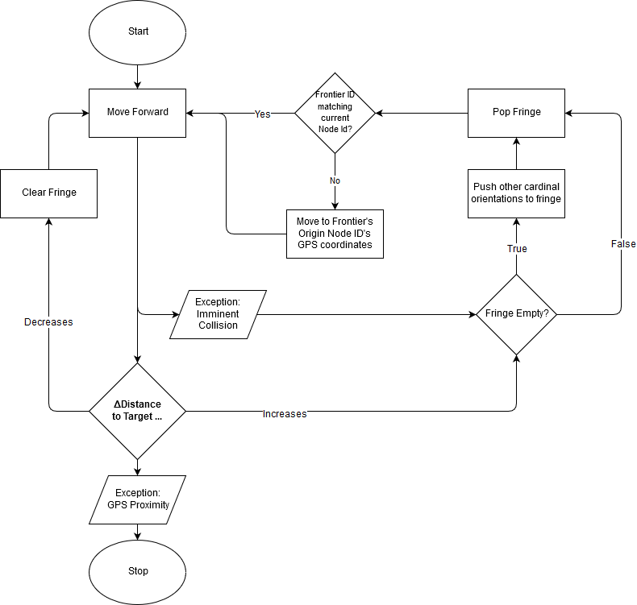
Fig. 6. Pathfinding Algorithm Flowchart

Unlike other Simultaneous Localization and Mapping projects, the SPARC makes no attempt to fully map its problem space; it would be a difficult endeavor give the openness of the operating environment, and ultimately a futile one as new, potentially permanent obstacles may be added between each delivery. The SPARC instead only explores new areas nominally when its preferred path is blocked by obstacles and will stick with a known, optimal path if at all possible. The optimal path for any one delivery is never assumed at start-up; new obstacles may always be encountered, so the decision making is done at run-time in each individual node and their utility is iteratively modified based on the amount of time taken to reach the endpoint.
Thus, the pathing algorithm utilizes this application of machine learning to iteratively change the preferred path when obstacles are encountered. The policy created from this should create preferred paths that encounter no obstacles.

V. Conclusion
The SPARC overall is made with easing the user in mind. It is a product meant to fix a simple problem by completely a simple task autonomously and efficiently with very little user input or interference in the vain of a present and future moving closer full autonomy of mundane tasks and chores to increase human progression and productivity.

The design and development process in creating a fully functional product is the basis of every engineering process. Researching by finding similar products, and weighing the benefits versus the consequences of using on device or component over the other, working as a group and dividing the development management in terms of individual strengths, building a prototype and testing it; all basic components of the engineering process.

VII. Acknowledgement
The authors wish to acknowledge the assistance and support of the ECE Department at the University of Central Florida.
Thanks and gratitude are offered to the professors who have so kindly agreed to review the SPARC project.
The authors wish to specially acknowledge our project sponsor, Selah Group Florida Inc, Power Systems and Automation Counseling, which made this entire project possible.

VIII. References
[1] "History | iRobot", http://www.irobot.com, 2018. [Online]. Available: http://www.irobot.com/About-iRobot/Company-Information/History.aspx. [Accessed: 26- Apr- 2018].
[2] D. Klein and P. Abbeel, “Lecture 8: MDPs I,” UC Berkeley CS188 Intro to AI. [Online]. Available: http://ai.berkeley.edu/lecture_slides.html.
[3] J. Tompkin, J. Hays, and M. Black, “Introduction to Computer Vision,” CSCI 1430: Introduction to Computer Vision. [Online]. Available: https://cs.brown.edu/courses/cs143/.

